Please read these instructions carefully, as they will help you figure out how to win money in this game.

**INSTRUCTIONS FOR BOMB/NO BOMB TASK (INITIAL LEARNING)**

In this experiment, you will be playing a decision-making game in which you can win and lose money. In the 1st stage of the experiment, you will not be able to influence your winnings at all – the computer will decide when you win money, and when you will lose. Your task is to learn to predict when you will win or lose, so that you can use this information to maximize your winnings in the *next* stage of the game.

The computer decides whether you win or lose on each trial based on two pieces of information. First we will explain what these two pieces of information are, and how they relate to the computer’s decision. Then, we will explain what you actually have to do, in this game.

**The computer decides whether to plan a ‘bomb’ in each trial, or not**

On each trial, the computer will make you an ‘offer’, consisting of 12 tokens and a background colour.

This is a token



The first thing the computer will do is decide whether to place a ‘Bomb’ in the offer or not. It will not make this decision randomly – the probability of the computer placing a Bomb in the offer is determined by the background colour. There are 6 different background colours, and each one indicates a different probability of there being a bomb planted. For some colours, this probability will be high; but for others, it will be low. The relationship between each colour and the probability will stayed fixed throughout the entire experiment.



On this trial, the computer has paced a bomb here

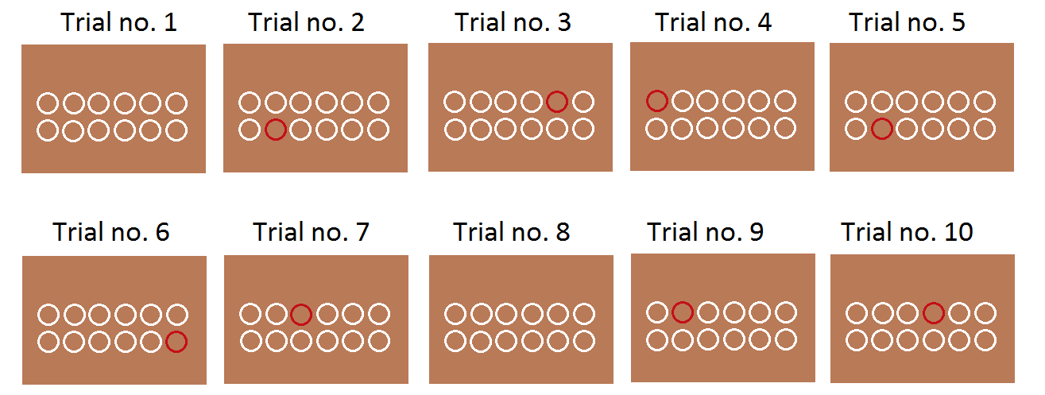For example, say this brown background indicates an 80% likelihood of a bomb being present. This means that if you saw a trial with a brown background 10 times, the computer would have put a bomb in the offer in 8 out of the 10 times. Like this:

If there is a bomb in the offer, there will only be ONE bomb. The bomb will be randomly placed under any one of the 12 tokens.

***What happens if there is a bomb?*** Bombs will sometimes cause you to lose money – but only sometimes. Whether a bomb causes you to lose money or not depends on whether it is ‘activated’. The background colour tells you nothing about whether a bomb is likely to be activated or not. To find that out, you need to look at other details in the offer – we’ll explain that now.

**The number of ‘activated’ tokens tells you how likely a bomb is to be ‘activated’**

On each trial, the computer will also decide how many tokens to ‘activate. The number of activated tokens will range from 2 to 12. ‘Activated’ tokens are filled in white, like this:



This offer consists of:

1. Brown background
2. 4 activated tokens out of 12 (coloured in white)

The number of activated tokens tells you two things. Firstly, it tells you how much money you will win on that trial, if the computer decides to give you money. Each activated token represents +10 p of money that you could win.

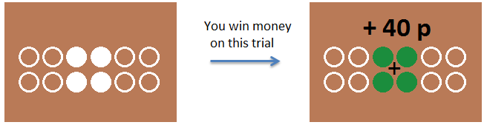

The number of activated tokens also tells you the likelihood of a bomb being ‘activated’, on trials where the computer has decided to plant a bomb. A bomb that is planted under one of the ***activated*** tokens (coloured in white) is ‘activated’, and will cause you to lose money. If the computer decides to plant a bomb, but it falls under one of the *inactivated* tokens, it will NOT cause you to lose money – on trials like this, you will still win.

On every trial, you will have to decide whether or not you think there is an activated bomb or not. It is only *activated* bombs that you should worry about - inactivated bombs will not cause you to lose money. To predict whether you will win or lose, you will need to pay attention to the background colour and the number of activated tokens.

***How exactly does the number of activated tokens affect my odds of losing?***

The likelihood of a bomb being ‘activated’ (if the computer has planted a bomb) is just a matter of probability:

*More activated tokens = Higher probability of there being an activated bomb*

*(given the same background colour)*

You can think of it as being similar to the odds of encountering a land-mine when walking across a dangerous plot of land. If there is a land-mine somewhere in the plot of land, your odds of setting it off would increase if you were to step on more places within the plot. If there IS a land-mine around, but you do NOT step on it, then it won’t go off, and you’ll be absolutely fine. And of course, if there are no land-mines at all in the plot of land (e.g. similar to Trial no. 1, in the picture on page 1), then it doesn’t matter how many places you step on – there is no bomb to set off, so you cannot possibly lose.

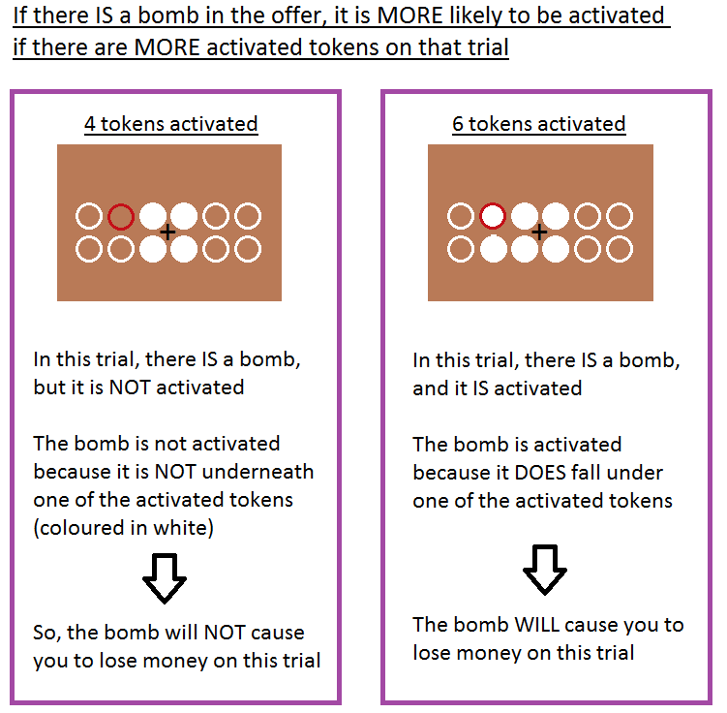

Stepping on more places in this plot of land is similar to having more activated tokens, in this game. The computer plants bombs on the different trials, with a probability indicated by the background colour. The background colour tells you about how ‘dangerous’ the trial is, generally – but even on dangerous trials, you won’t necessarily lose money. For any given background colour, increasing the number of activated tokens increases the odds that you will encounter an activated bomb, and lose money. Depending on how dangerous the trial is generally (as indicated by the background colour), more activated tokens may or may not mean that you are likely to encounter an activated bomb and lose money overall.

All in all, this means that with more activated tokens, the odds of losing go up. More activated tokens also means more money that you could potentially win, however. Thus there is an inherent trade-off between your potential winnings and the risk involved.

**How do I play this game?**

Now you know how the game works – how the computer decides whether you win or lose on each trial. Now we will show you how each trial will work.

On each trial, the computer will not show you the bombs straightaway. Each trial will go like this:

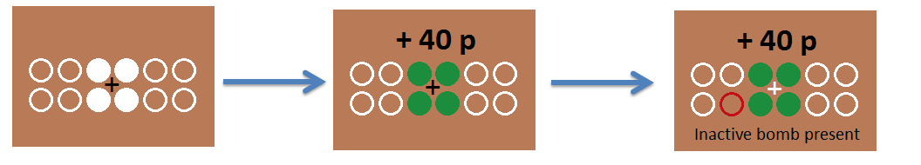

First, it will show you the offer itself, consisting of the background colour & number of activated tokens. Then it will show you how much money you won or lost, on that trial. Then, it will show you whether there were any inactivated bombs or not. For each trial, you should try to figure out whether you think there is likely to be an activated bomb or not. For trials where there is an activated bomb, you will lose – 120 p.

The inactive bombs do not have any effect on whether you win or lose money. We show you the inactive bombs because we want you to figure out, over the course of this session, how likely there is to be a bomb (activated or not) given each of the 6 different background colours. By the end of this session, you should be able to rank the colours in order of ‘best’ (least likely to have a bomb) to worst.

On trials where you lose money, we will not show you inactivated bombs, because you should already know that there was a bomb under one of the activated tokens.



Note: If it isn’t clear to you how you would know whether there is a bomb (activated or not) on each trial, please ask the experimenter for more explanation!

**Also: Look out for the white cross**

While you are trying to figure out which colours are good and bad, you will also have to look out for the cross in the middle of the screen. Sometimes, this cross will turn white in colour – press the DOWN ARROW every time you see this cross turn white.



**To summarize**

Here is a summary of how the computer decides whether you win or lose on each trial:

1. The computer will decide whether to plant a bomb or not, as indicated by the background colour.
2. The number of activated tokens tells you how much money you could win on that trial, as well as how likely a bomb is likely to be activated (if there is a bomb there at all).
3. Activated bombs cause you to lose money (- 120p at a time), but inactivated bombs have no effect on whether you win or lose on that trial.

In this session, you will have to:

1. Look out for the white cross in the centre of the screen
2. Figure out how likely there is to be a bomb, given the 6 different background colours

By the end of this session, you should have a good idea how likely there is to be an *activated* bomb, given different combinations of background colour + number of activated tokens.

This information will be very important in helping you win money in the next stage of the experiment.

In the NEXT stage of the experiment, you will be able to avoid trials where you think there is likely to be an activated bomb. This is why it is important that you use this session to figure out when there is likely to be an activated bomb.

The extra money that we pay you at the end of this experiment will be proportional to the amount of money that you win on all the games in the experiment, so it’s important that you learn this game well, and win as much money on it as you can.

**This is a complicated game, and it’s important that you understand clearly how it works – you will lose a lot of money otherwise! Please ask the experimenter if anything is unclear about the game so far.**

**Instructions for Stage 2**

Please read these instructions carefully, as they will help you figure out how to win money in the task.

By now, you should have a good idea of how likely there is to be an 'activated' bomb, given combination of background colour and number of tokens. By now, you should have a good idea of how likely there is to be an activated bomb, given combination of background colour and number of tokens. In this stage of the experiment, these same likelihoods apply'

i.e. If a certain combination of background colour & number of activated tokens meant a good chance of there being an activated bomb in the previous stage of the experiment, it will indicate the same thing in this stage of the experiment. Thus, if a certain combination of background colour & number of activated tokens meant a good chance of there being an activated bomb in the previous stage of the experiment, it will indicate the same thing in this stage of the experiment.

In this stage of the experiment, however, you will perform a slightly different task. Now you will learn how this task works

On each trial, the computer will make you an offer, consisting of a number of activated tokens and a coloured background. Like before, the background colour indicates the probability of there being a bomb in the offer. Just like in the previous stage, more activated tokens means greater potential winnings, but also a greater likelihood of encountering an activated bomb.

Note: The offers indicate both (a) the amount of money you can win as well as (b) how likely you are to win or lose. Please ask the experimenter if you’d like a reminder of how the game works!

When you see the offer, you should have a rough idea about whether there is likely to be an activated bomb or not - since you’ve learned this in the previous stage of the experiment. For each offer, you have the option of Accepting, Rejecting, or Exploring the offer. Make your choice by pressing the Left, Down or Right arrow respectively (with your RIGHT hand)

If you ACCEPT an offer with no activated bomb you will win money - 10p per activated. But if you Accept an offer WITH an activated bomb, you will LOSE money. Each time this happens, you will lose 120p. The computer will tell you whether you have won or lost money, on each trial.

You can also Reject offers, to avoid losing money. If you Reject the offer, you will not win or lose any money, no matter what outcome goes with the offer. Also, the computer will NOT tell you what outcome you would have gotten, if you had accepted the offer

If you always Reject offers, however, you will never win any money. Sometimes it’s better to Explore'

If you choose to Explore, the computer will give you more information, before you choose to Reject or Accept the offer. The computer will reveal the status of 50% of the activated tokens offered, showing whether there are bombs or not, underneath these tokens. For each token, a green outline indicates NO bomb while a red outline indicates a bomb. After you learn the status of half of the activated tokens, you will then have to decide whether to Accept or Reject the offer

Once again, you will receive the associated outcome if you Accept the offer, but you will not win or lose money (nor learn what the outcome would have been) if you choose to Reject the offer. The computer won’t tell you about inactivated bombs either, in all the rest of the experiment. They won’t have any effect at all on your winnings, throughout the experiment

The information gained by Exploring can help you decide if it is worth risking loss, to gain more money. This information is not free, however! Each Explore' choice will cost you 20p regardless of whether you decide to Accept or Reject the offer later on. If you use the Explorations well, you will end up winning more money overall, so it’s worth your while to try it out if you feel like you’d like more information before making your decision

You will have TWO seconds, for each response you have to make. If you do not respond in time, the trial will be stopped, and you will have to redo that trial again later in the game. Don’t worry if it seems like it’s going very quickly at first! You will get used to the pace and if you are too slow on a trial, you won’t lose, any money because of it. All that will happen is that you will have to do it later

Remember, you are playing for real money in this game - the amount of extra money we pay you at the end of this experiment will be proportional to your winnings in this game. Therefore, you should whatever you think would be the most likely to win you money on every single trial!

**Instructions for Stage 3**

By now, you should have a good idea of how likely you are to encounter an activated bomb, given each type of background, as well as each combination of background colour and number of activated tokens

In this stage of the experiment, these same likelihoods apply. i.e. If a certain combination of background colour & number of activated tokens meant a good chance encountering an activated bomb in the previous stage of the experiment, it will indicate the same thing in this stage of the experiment

In this stage of the experiment, an activated bomb will NOT always lose you money. Your job in this stage of the experiment is to decide whether or not you think there is an activated bomb or not, on each trial. You will win money for correctly predicting whether there is an activated bomb on each trial

On each trial, the computer will show you the offer, consisting of a number of activated tokens and a coloured background. Press the Z key if you think there is NO activated bomb in the offer, or the X key if you think there IS an activated bomb in the offer. Use your LEFT HAND for this task. Press the Left arrow key if you think there is NO activated bomb in the offer, or the DOWN arrow if you think there IS an activated bomb in the offer. Use your RIGHT HAND for this task

For every trial where you correctly predict whether or not there is an activated bomb, you will win money. The amount of money you win is proportionate to the number of activated tokens (10p per token. For every trial where you are INCORRECT in your guess, you will NEITHER win NOR lose money. Unlike in the last stage of the experiment, you will NOT lose any money in this task.

You can also choose to Explore, if you''d like more information before making your guess. Press the C key with your left hand, if you''d like to Explore. If you choose to Explore, the computer will reveal the ''status'' of 50% of the activated tokens, showing whether there are bombs or not, underneath. A green outline indicates NO bomb, while a red outline indicates a bomb, underneath each token. After you learn the status of half of the activated tokens, you will then have to decide whether you think there is likely to be an activated bomb or not, on that trial.

The information gained by Exploring can help you decide which response to make. The information gained by Exploring can help you decide which response to make. But this information is not free - each ''Explore'' choice will cost you 20p, regardless of what choice you make after that

You will have TWO seconds, for each response you have to make. If you do not respond in time, the trial will be stopped, and you will have to redo that trial again later in the game.

In this stage, every single trial has equal influence on how much extra money you win on the task. The amount of extra money we pay you at the end of the experiment is proportionate to the total amount of money you win on these tasks. This means that every trial counts for real money and you should try your best to do whatever would be the most likely to win you money on every single trial